Heart Failure Protocol

How to pick it up

A little background information might help:

The estimated prevalence of heart failure in the general population reaches from 0.4 to 2%. In the over 65s it reaches 10%. The prognosis of heart failure is quite poor: 20 -30% mortality at one year for mild to moderate heart failure and 50% in severe heart failure.

Causes:
- CHD 45%
- Hypertension 18%
- Valvular heart disease 9%
- Cor pulmonale 7%
- Cardiomyopathy 2%
- Metabolic causes 2%

Precipitating factors ( acute and chronic )
- Infection
- CVD event
- Arrhythmia: AF
- Anaemia
- Thyroid disorder
- Alcohol excess
- Iatrogenic

History: Enquire about the following
- Breathlessness on exertion / at rest ( use NYHA classification – see review )
- Nocturnal dyspnoea and orthopnoea
- Peripheral oedema
- Fatigue
- Anorexia
- Weight gain
- Palpitations

Examination
- Cardiovascular examination: check for ventricular heave, displaced apex beat, murmur and 3rd HS / gallop rhythm, pulse for tachycardia and arrhythmias especially AF, elevated JVP
- Respiratory examination: especially looking for bibasal crepitaions, remember the possibility of ‘cardiac asthma’
- General examination: peripheral oedema, signs of anaemia, hepatomegaly and ascites

NB: the aim is to diagnose heart failure as early as possible before the pulmonary oedema with ‘barn door signs’. This however can be very difficult. Always think of heart failure in a patient with predisposing history and complaining of breathlessness. Initial symptoms can be as subtle as fatigue and anorexia. Also most clinical signs will be absent in early disease: the most sensitive sign being a displaced apex beat.

If you think it is heart failure: Refer to practice nurse to get the following investigations.

Nurse appointment

- Record smoking status, alcohol intake and FHx
- Give appropriate lifestyle advice ( see other protocols for details )
- Record weight
- Obtain blood sample for FBC, U/Es, Glucose, TFTs and LFTs
- Record 12-lead ECG: 90% of patients with heart failure will have an abnormal ECG, especially look for signs of LVH, evidence of previous myocardial damage and arrhythmias such as AF. Read code 32.
- Send for a CXR

Back to GP with results

- Check results and make a diagnosis:

Echocardiography would be regarded as the gold standard in the diagnosis of LVF however there is currently no direct access from primary care for this service. A suggested pragmatic method of diagnosis in this setting follows:

- If the CXR clearly shows changes consistent with LVF then treat as LVF.
- If the CXR suggests changes more consistent with respiratory illness pursue that diagnostic line unless strong clinical suspicion, in which case refer to cardiologist for ECHO
- If CXR normal except abnormal C/T ratio refer to cardiologist for Echo
- If CXR normal review ECG
- If ECG normal consider alternative diagnosis. May be appropriate to check RFTs or ETT if exertional breathlessness. If no other clear diagnosis consider referral to cardiologist for assessment.
- If ECG reveals LBBB or previous Q wave infarction, with strongly suggestive LVF. Code and treat as LVF
- If ECG reveals LVH consider referral to cardiologist for ECHO

- Educate patient and carer: see PIL
- Consider stopping other treatments such as tricyclics, NSAIDs and calcium channel blockers
- Reinforce lifestyle advice
- Make patient aware of necessary vaccinations such as influenza and pneumococcus
- Use appropriate read codes: heart failure G 58. ECHO 5853.
- Commence treatment ( you might have done this already )

1. Diuretics: use loop-diuretics according to symptoms ( Frusemide 20mg for mild symptoms and 40 – 80mg for more severe symptoms. Most effective measure to control symptoms. Avoid combinations with a potassium sparing diuretic as this is usually unnecessary and might add to the potassium retaining effect of ACE inhibitors. This does not include Spironolactone which has been shown to reduce mortality in cases of severe heart failure ( NYHA III and IV ) and should be added at a dose of 25mg once daily. Do not forget to check U/Es for potassium retention after 2 weeks.

2. ACE inhibitors: should be started in everybody with LV dysfunction without contraindications as there is evidence that the mortality of heart failure is reduced by about 30%. The PCT agreed drugs include Lisinopril and Ramipril. It is important to titrate the dose to the maximum allowed or to the highest tolerated dose ( to match effective study doses ). This is Lisinopril 40mg daily and Ramipril 10mg daily. How to titrate and monitor see separate protocol for ACE inhibitors. Note ACE inhibitors will not make a great impact on symptoms and should only be added once symptoms are controlled.
Angiotensin-II-receptor antagonists: there is also evidence that they work roughly as well as ACE inhibitors but because of financial implications there use should be restricted to patients intolerant of ACE inhibitors.

3. Beta-blockers: have also shown to reduce mortality in heart-failure and in most cases do not increase the symptoms contrary to common belief. Although the BNF states that beta-blockers should only be introduced by specialists our local cardiologists have expressed that this could be done by GPs. Should be introduced in patients with NYHA grade II and III. Note: start low and go slow. Bisoprolol 1.25mg once daily increased by 1.25mg at four weekly intervals unless symptoms worsen.

(Digoxin: can be introduced as adjunct treatment. The evidence around Digoxin is generally poor. It seems that Digoxin has no positive effect on mortality and there is some evidence that it improves symptoms slightly and perhaps reduces hospital admissions by a little. Only to be considered if symptoms can not be controlled satisfactory otherwise.)

Other drug treatment like Aspirin, Warfarin, statins, antihypertensives etc. use according to underlying diseases and use appropriate protocols.
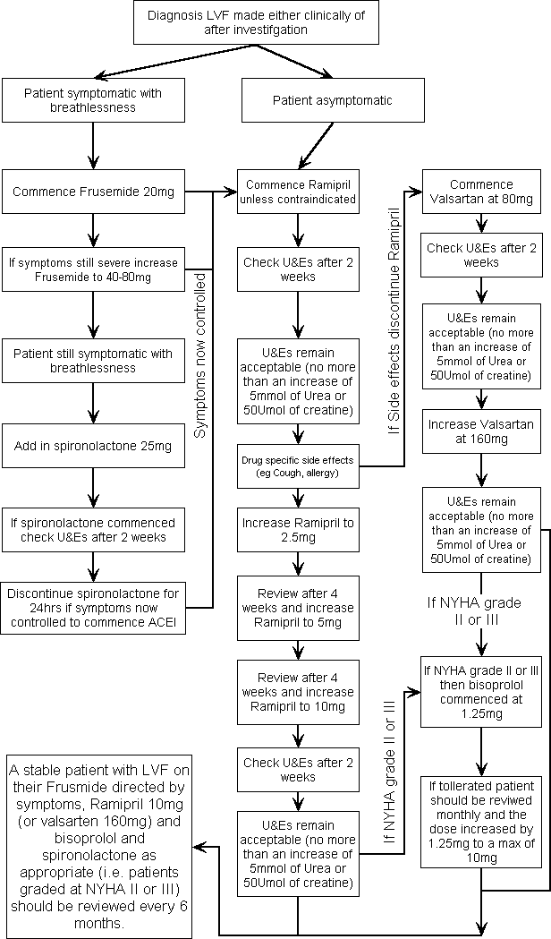
Follow-up:
Refer to nurse for ACE inhibitor titration and symptom monitoring. Practice nurse will contact GP once this has been completed successfully. The GP can then decide on the introduction of a beta-blocker. The Practice Nurse can also contact the GP at any stage if problems in terms of symptom control or adverse drug reactions etc occur.
Following the introduction of all protective drugs and the achievement of symptom control the patient can be given a review date in 6 months using the diary entry and Heart Failure template.

First protocol written on 12.4.2002, changed according to agreed NBPCT heart failure protocol on 25.7.2002.

